# Project Management Report (Group 5) – Happiness, Alcohol & PISA

## Introduction & overview:

1. Data and goal of the project:

Our project is based on three studies from 2015.

The first one is the *‘World Happiness Report’*, which “*asks respondents to think of a ladder with the best possible life for them being a 10 and the worst possible life being a 0 and to rate their own current lives on that scale. […] The columns following the happiness score estimate the extent to which each of six factors – economic production, social support, life expectancy, freedom, absence of corruption, and generosity – contribute to making life evaluations higher in each country than they are in Dystopia,* […].”

Next is a dataset on the *alcohol consumption* of people from different countries from the age of 15 and above. Total liters of pure alcohol and different kind of servings, e.g. beer or wine are distinguished.

The last dataset is the *PISA – “Program for International Student Assessment*” study, which “[…] *is applied to 15-year-old students across the world to assess their performance in Math, Reading and Science.”.*

Having these three categories and 67 countries to compare, we want to find out, whether there are any correlations between the people’s happiness, school performance and alcohol consumption. Furthermore, we want to give general insights into the datasets by visualizing the data descriptively.

1. Customers

We see everyone reading our report as our customers, especially Associate Professor Dr. Lele Kang and our fellow students.

1. Costs of the Project

Since this project is conducted by students during assigned study hours, no monetary costs are involved.

1. Time constraints

The due date of the project is the 22nd of June, where the results will be presented before the entire class.

1. Usefulness

We see our project as useful to everyone who wants to know more about happiness, PISA, alcohol consumption, and how all these components may correlate. It might be interesting from a personal as well as from a sociological perspective

1. Maintenance

To keep the data up-to-date, it will be necessary check for new releases of the studies we are using. It might be interesting to see development and changes that can occur. Moreover one has to take into account potential updates on the R packages that we use, editing deprecated functions should they occur.

1. Risks involved

The highest risk of the project is to disappoint our customers by not providing insightful analysis or even doing mistakes. It, too, important to create an understandable analysis and report.   
We endeavor to deliver a high-quality analysis and a comprehensible and comprehensive analysis.  
Also, we are aware that there might be unpredictable risks.

## Project Management

1. Overview

To aid our time - and team management, we used different tools. On the one hand we made use of ‘GitHub’ (github.com) for code synchronization an allowing parallel programming. On the other hand, we used ‘Trello’ (trello.com) to manage different tasks along the team members and to simplify communication on those tasks. In between the ‘coding sessions’, mostly after one Trello Card reached the List “Finished”, we held code review meetings, to assure quality and minimize the risk of bugs.

1. Introduction into ‘trello’

‘Trello’ is a web-based project management application, used for a variety of work and personal uses. It is based on:

A) ‘Boards’ which represent a project  
B) ‘Lists’ that keep ‘Cards’ organized in their stages of the progress  
C) ‘Cards’ that are used to represent tasks and ideas  
D) The ‘Menu’ that is the control center of the ‘Board’

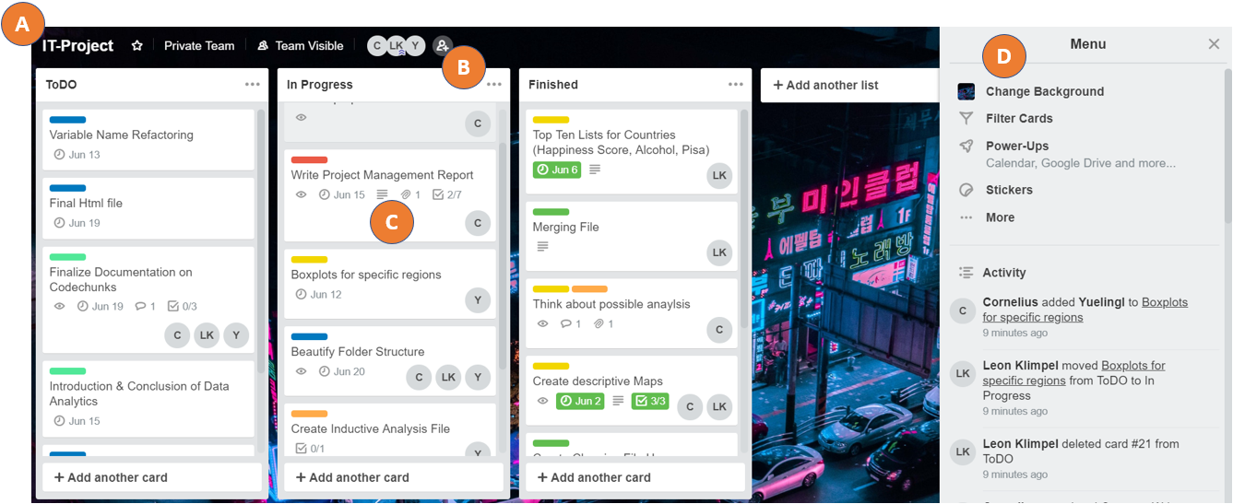  
 (Overview of our Trello-Board)

As Lists we chose to simply take ‘ToDO’, ‘In Progress’ and ‘Finished’, to keep an overview of our Cards. Our Cards are labeled ‘Cleaning’, ‘Descriptive’, ‘Inductive’, ‘Project Management’, ‘Refactoring’, ‘Description & Analysis’ and ‘No Labels’, to quickly categorize our tasks. We also made use of functions to assign group members to Cards and give those Cards due dates. Usually we add descriptions, attachments, checklists and comments to clarify a task. In this way we enhance our communication.

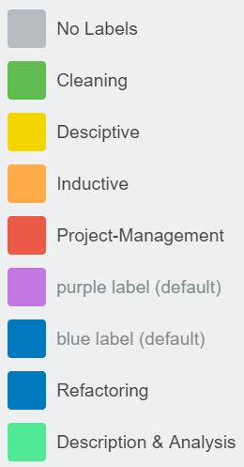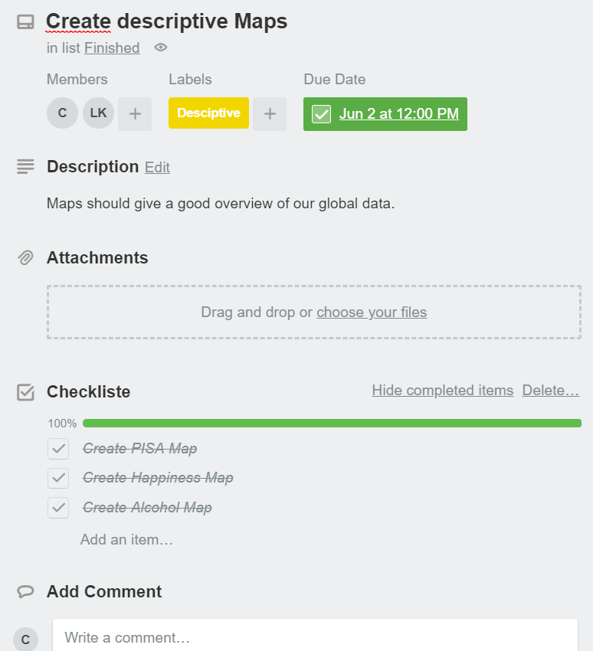

1. Milestones and time management

Being a rather small group of three people with a rather small IT project, we had no problems managing time and doing enough progress. Therefore, we refrained from having a strict schedule.

To still synchronize and keep track of our progress, we chose to establish at least some milestones:

* 1st of June 2018: Have all the cleaned data ready and merged into one file
* 8th of June 2018: Have all the analysis parts
* 15th of June 2018: Have the whole documentation (Project Management & Data Analytics)
* 21th of June 2018: Have the presentation ready and practiced

Furthermore, we kept track of all subtasks and minor milestones via Trello and its “due date”-option for Cards.

1. Roles in the team

Again, being a small project team with similar abilities, we chose to not have fixed roles and rather just all begin on the planning and programming part together. Having three group members and three data sets, each of us had one data set to clean. Continuing with the analysis part, we sat together and discussed ideas. Then each of us started with descriptive and analysis functions in R. Later we split or responsibilities further, with Leon Klimpel and Yueling Li deepening their focus on the analysis programing and Cornelius Schäfer starting with the Project Management documentation. Later we discussed the results of the analysis together and prepared our presentation together.